Helpful YouTube clips - Communication and strategies to support SCD/ASD
 | 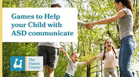
  Games to Help your Child with Autism Communicate
youtube.com

 | 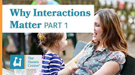
  Why Interaction Matters - Part 1
youtube.com

 | 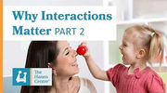
  Why Interaction Matters - Part 2
youtube.com

 | 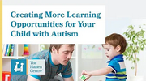
  Creating More Learning Opportunities for Your Child with Autism
youtube.com

Visuals

 | 
  NHS Elect - Speech and Language Therapy Videos
nhselect2.org.uk

 | 
  Adding meaning to communication « AET Training Hubs
aettraininghubs.org.uk

Useful communication resources and websites
Microsoft Word - Early Support SLCN FINAL.doc

councilfordisabledchildren.org.uk

 | 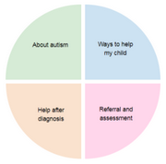
  Autism, Speech, Language and Communication Needs | Care and Support in Cornwall
supportincornwall.org.uk

 | 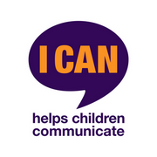
  I CAN, the children's communication charity
ican.org.uk

 | 
  Communication Matters – Communication Matters is the working name of ISAAC (UK)
communicationmatters.org.uk

 | 
  The Hanen Centre | Speech and Language Development for Children
hanen.org

Afasic – Voice for Life

afasic.org.uk

 | 
  Communication
autism.org.uk

